Project 2 Proposal

Project members: Trip Beernink, Lauren Calso, David Colonia, David Cruz, Phillip Sohn

Title: San Francisco

Topic: Our project is a rendition of a San Francisco map with layers that can help people visiting or thinking of moving to the city. In this map, you can select various layers to determine which area seems more attractive. The map layers include light, dark, satellite, and street views. The markers include bike share stations, reported crimes, tourist attractions, and restaurants.

Rationale: This interactive website will verify the location of bike share stations, reported crimes, tourist attractions, and restaurants by using plotly to mark sharing stations in the Bay Area.

Data Set (must have at least 100 records):

All datasets were from data.gov

Converted CSV to JSON file for all datasets below:

Bike share stations: 190

Reported crimes: 1,000

Tourist attractions: 5

Restaurants: 432

Screenshots of relevant visualizations:

Visualizations include:

* Python, Flask, SQLAlchemy
* HTML/CSS, Bootstrap, JavaScript

JS library: Mapbox.js, D3.js, Leaflet

Sketch of final design:

Dashboard page with multiple charts all updating from the same data

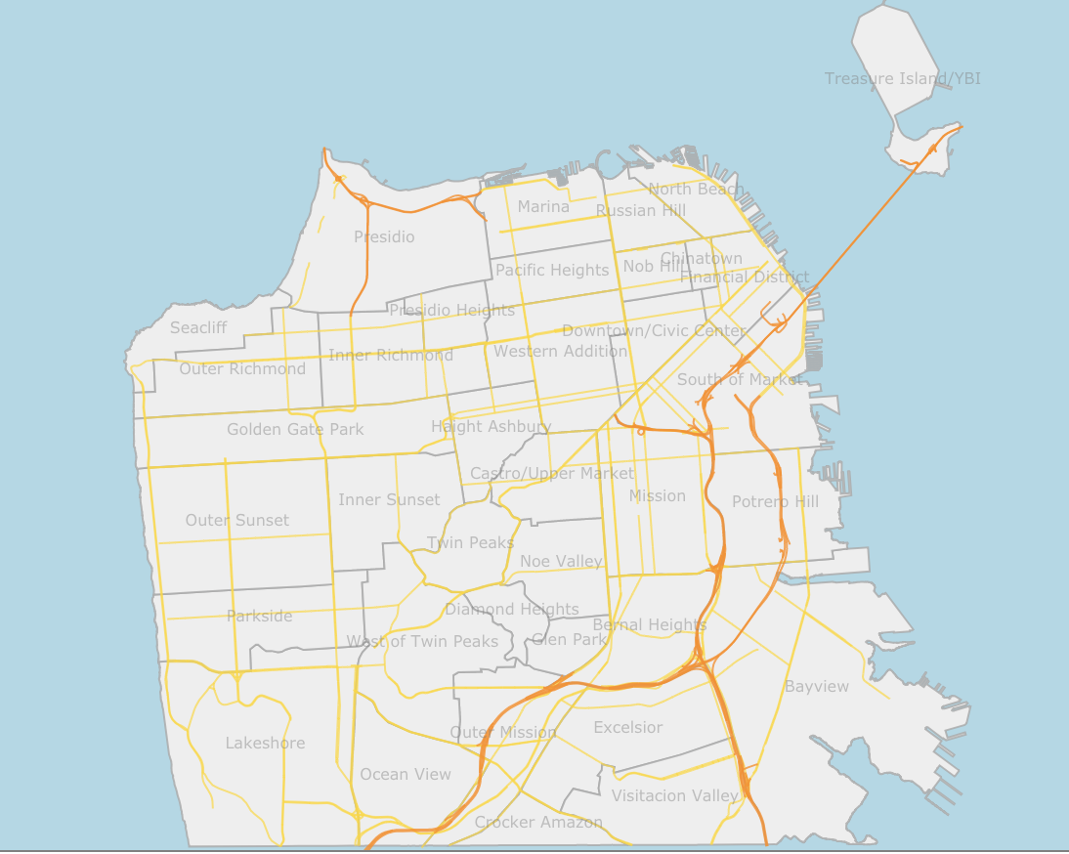

GitHub project 2 repository: https://github.com/LCalso/Project-2_Bike-Project